**Member Invoke functionality contain two Activity:**

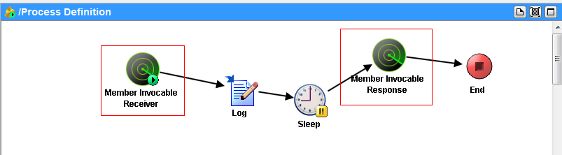

**Member Invoke Receiver(EventSource):**

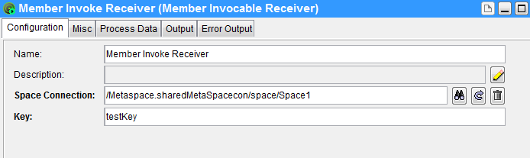

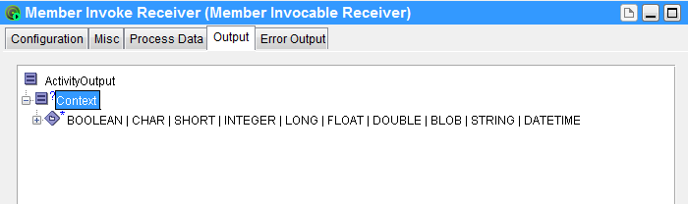

Params:

Space Connection:space connection

Key: Distinguish between different invoke

Context: from remote invoke client

**Member Invoke Response:**

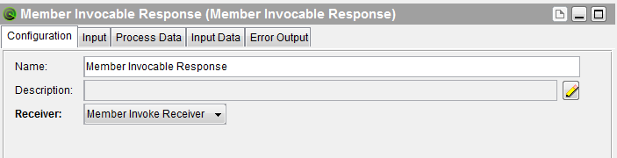

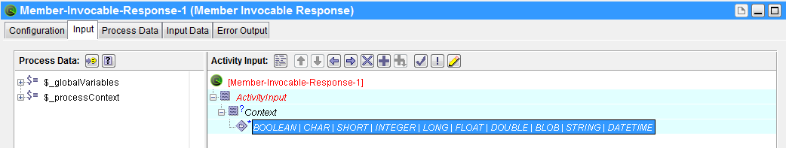

Params:

Receiver:Member Invoke Receiver

Context: will be return to remote invoke client

**Sequence diagram:**

init Member Invoke Receiver:

1. connect metspace and getSpace
2. put ASMemberInvocableReceiver to ConcurrentHashMap(key=spaceName+key)
3. set isActive = true

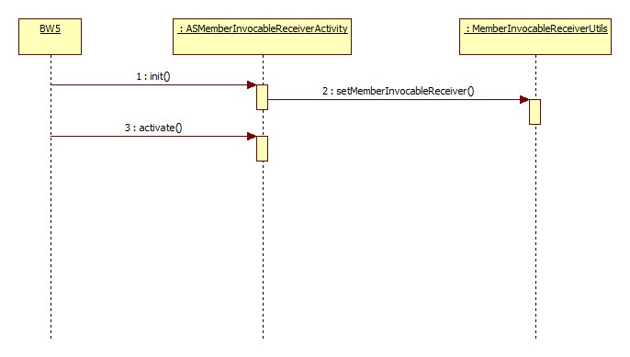

run steps:

1. run remote invoke test client
2. the context must contain ASMemberInvocableReceiverKey
3. member invocable class must be com.tibco.plugin.as.invocable. ASMemberInvocable

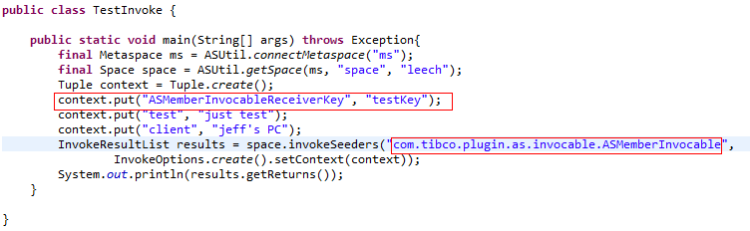

1. get key from context,this key is similar with the key which is defined in Member Invoke Receiver Activity,the value of the key is from **TestInvoke**
2. get Member Invocable Receiver Object from ConcurrentHashMap(key=spaceName+key)
3. add CountDownLatch to ConcurrentHashMap and generate a token
4. invoke Member Invocable Receiver Object newEvent method

params:context,token

1. wait for countDown
2. get result tuple from input
3. set result tuple to ConcurrentHashMap(key=token)
4. countDown and remove CountDownLatch from ConcurrentHashMap(key=token)
5. take result tuple from CountDownLatch(key=token)
6. return result tuple

